

Project Report
ONLINE EXAMINATION SYSTEM

Submitted by
Shubh Yadav (24csu196)
Sakshar Bhatnagar (24csu180)
Saumay dev (24csu187)

DEPARTMENT OF COMPUTER SCIENCE AND ENGINEERING,
SCHOOL OF ENGINEERING AND TECHNOLOGY

THE NORTHCAP UNIVERSITY
GURUGRAM-122017

Table of Contents
- Abstract
- Introduction
- Problem Statement
- Social Relevance
- Training Description
- Working & Features
- Experimental Results
- Analysis
- Conclusion
- References

Name | Roll No. | Responsibility | Github Links
Sakshar Bhatnagar | 24CSU180 | Loops and functions | https://github.com/saksharr-17
Shubh Yadav | 24CSU196 | Class designs and Constructors | https://github.com/shubh-ncu
Saumay Dev | 24CSU187 | GUI Integration | https://github.com/Saumaydev

Abstract
The core objective of this project was to gain hands-on experience in advanced Java programming and GUI application development using Java Swing. The project titled “Online Examination System” enables students, teachers, and administrators to interact with a digital exam platform.
The system supports functionalities such as creating exams, adding questions, assigning exams, auto-scoring objective questions, manual grading of subjective questions, tracking student results, and providing analytics.
Through this project, I enhanced my understanding of Object-Oriented Programming, Swing GUI development, data structures, interactive components, state management, event handling, and multi-role system design. This project strengthened my logical, analytical, and software development skills.

INTRODUCTION
As part of the Bachelor of Technology curriculum, I developed an end-to-end Java application using Java Swing and Object-Oriented Programming (OOP) principles.
The application — Online Examination System — is a full-fledged desktop-based examination platform that supports:
- Student login & exam participation
- Teacher-driven exam creation and question management
- Admin user management
- Automatic and manual grading
- Secure exam session handling with timers
- Analytics and reporting
Java Swing is a powerful GUI framework used for building desktop applications. This project allowed me to explore event-driven programming, UI layouts, model–view interactions, data validation, and component customization.
This project provides a real-world simulation of digital examination systems like those used in universities and competitive exam portals.

PROBLEM STATEMENT
Manual examination processes such as paper-based tests, physical evaluation, and manual result compilation are time-consuming, inefficient, error-prone, and difficult to manage at scale.
Key issues in traditional systems include:
- Difficulty in managing large numbers of papers
- Human errors in grading
- Lack of transparency
- Slow result generation
- No automated analytics
To address these inefficiencies, a computerized Online Examination System is needed to:
- Create exams digitally
- Record student answers
- Auto-score objective questions
- Allow teachers to grade subjective responses
- Provide instant results and insights
- Maintain role-based secure access
This project solves all these challenges using a structured Java-based system with a clean GUI and internal data handling.

SOCIAL RELEVANCE OF THE PROJECT
An online examination system digitizes testing processes and is highly relevant for:
- Schools, colleges, and universities
- Training canters
- Online certification platforms
- Recruitment examinations
- Mock test canters
The solution:
- Increases efficiency
- Reduces cheating
- Removes human error
- Saves paper
- Enables remote exams
- Supports instant evaluation
By automating examination workflows, educational institutions can improve fairness, transparency, and productivity.

TRAINING DESCRIPTION
Nature of Work
The project involved designing and coding a complete multi-role Java Swing application. The system includes a login interface, admin dashboard, teacher dashboard, student dashboard, dynamic card-based UI, exam runner dialog, and internal data model.
Goals of the Project
- Understand Swing GUI development
- Implement object-oriented modular design
- Develop role-based access control
- Build exam creation and question storage
- Implement auto and manual grading
- Manage exam sessions securely with timers
- Create analytics and reporting
Methods and Approach
- Object-Oriented Programming: Data classes (User, Exam, Question, Session, Grade)
- Swing GUI: Card Layout, Panels, Buttons, Combo Boxes, Tables
- Event Handling: ActionListener, Window Listener, Timer events
- Internal Storage: Arrays for managing all entities
- Custom UI Components: Gradient headers, modern buttons, styled tables
- Auto Grading Logic: Based on matching correct indexes
- Manual Grading System: Dialog-based scoring input
- Analytical Processing: Calculation of average, min/max, and difficulty levels
Key Java Concepts Used
- Swing & AWT
- OOP (Inheritance, Class Models)
- Event-driven programming
- Java Timer
- Custom rendering in tables and panels
- Card Layout for navigation
- Exception handling
- Internal data storage

SYSTEM FEATURES
1. Admin Features
- Add/view users
- Create exams on behalf of teachers
- View all exams in the system
2. Teacher Features
- Create exams
- Add various question types
- Publish exams
- Assign exams to students
- Manual grading of subjective answers
- View exam analytics
- View list of created exams
3. Student Features
- View assigned exams
- Start exam with countdown timer
- Answer MCQs, True/False, and Subjective
- Submit and view grades
4. Automatic Features
- Auto-grade objective questions
- Prevent double attempts
- Timeout submission
- GUI navigation & progress

SYSTEM ARCHITECTURE
1. Data Layer
- Arrays store Users, Exams, Questions, Sessions, Grades
- Auto-increment IDs
- Session-based answer recording
2. Presentation Layer (Java Swing)
- Login Panel
- Dashboard per role
- Teacher/Student/Admin modules
- Styled tables
- Exam runner dialog with timer
3. Logic Layer
- Auto scoring engine
- Session management
- Manual grading
- Assignment system
- Role-based action routing
- Analytics computation

RESULTS
The system was fully tested with multiple roles. Key screens include:
- Login Screen
- Admin Dashboard
- Teacher Dashboard
- Student Dashboard
- Exam Creation
- Question Addition
- Publishing
- Assigning exams
- Manual grading screen
- Analytics screen
- Exam runner with timer
- Results and Scores

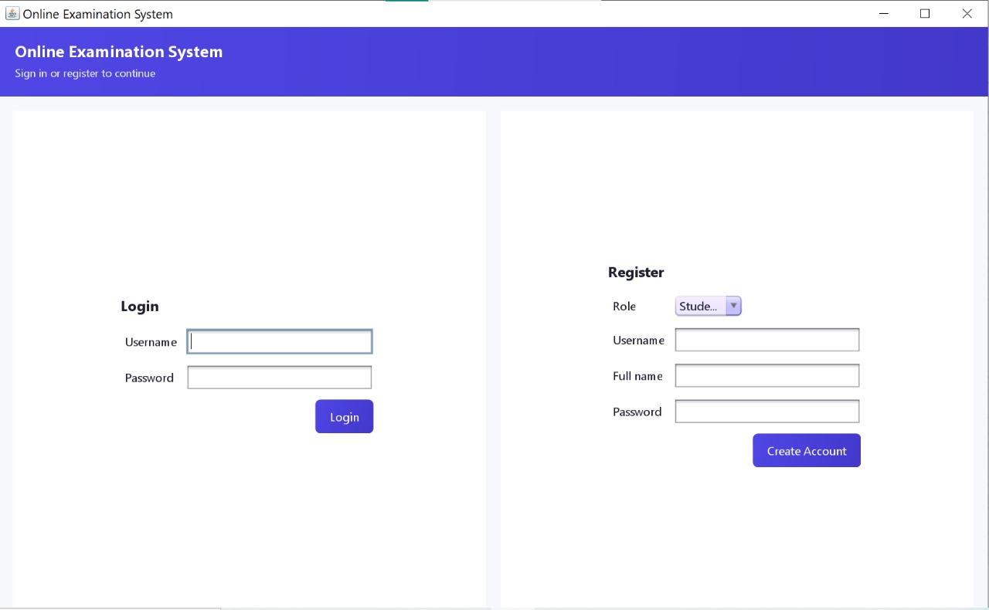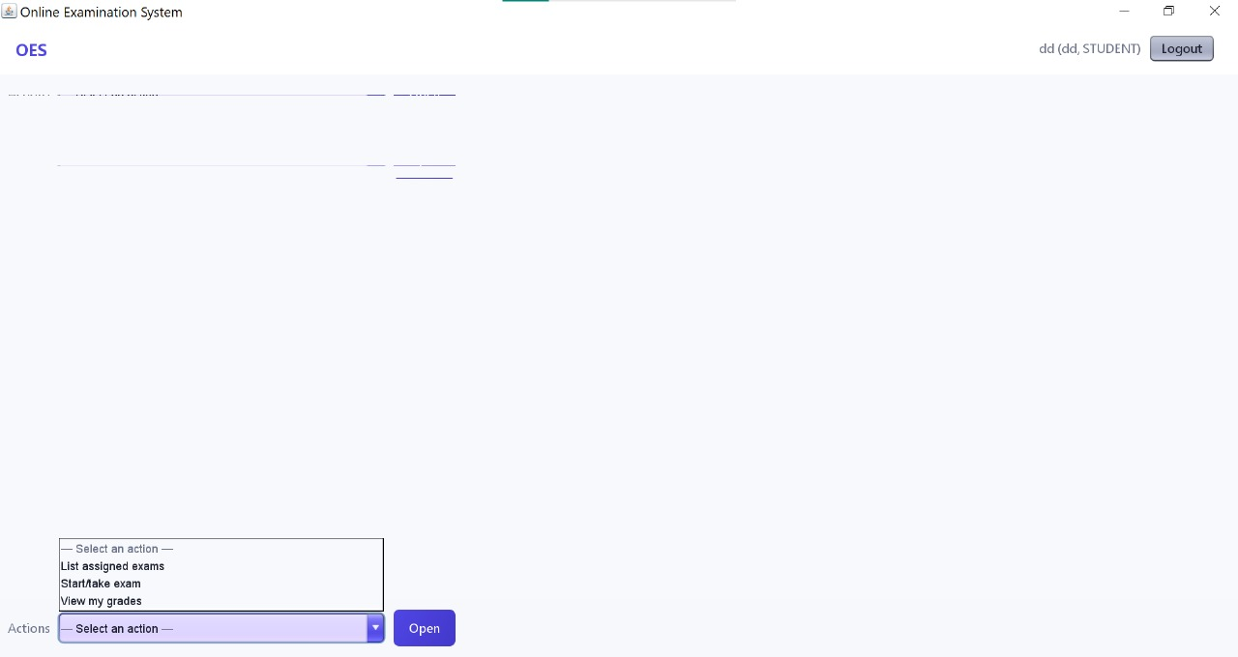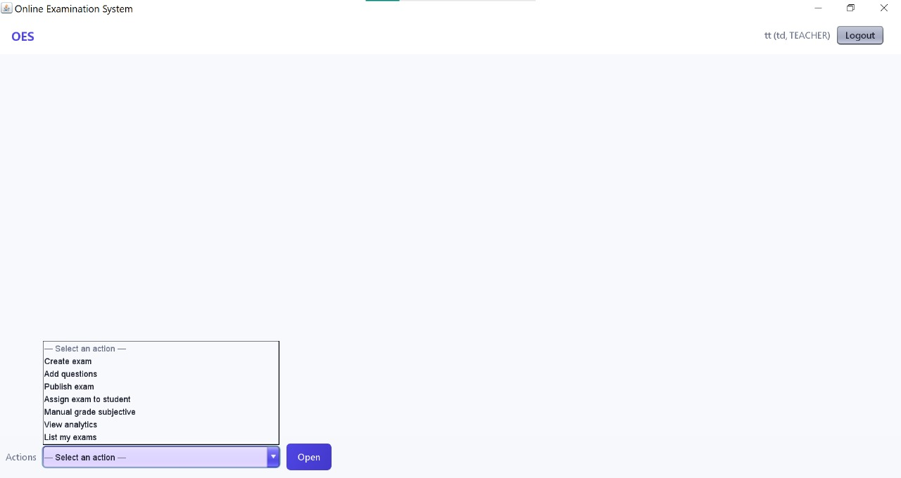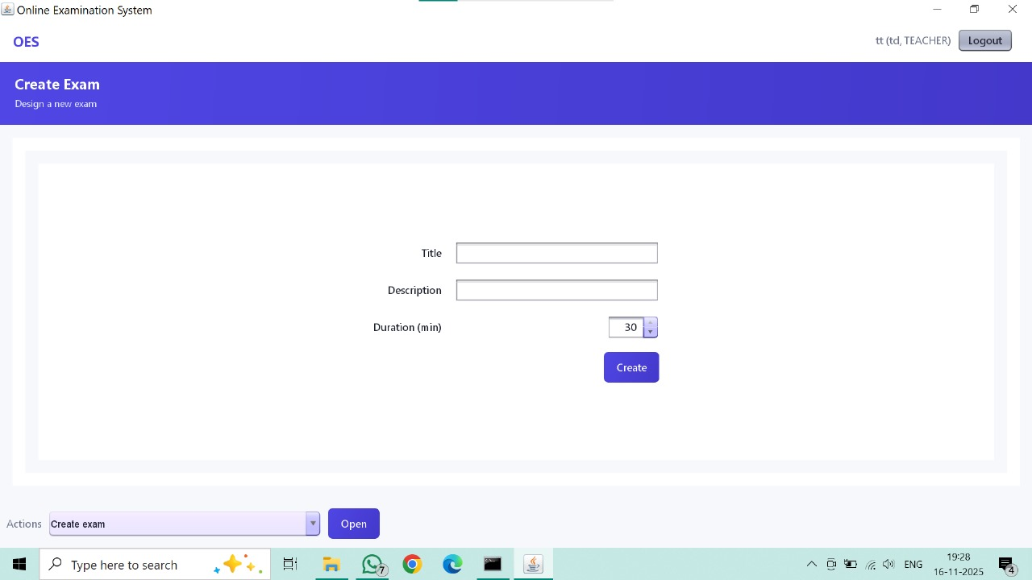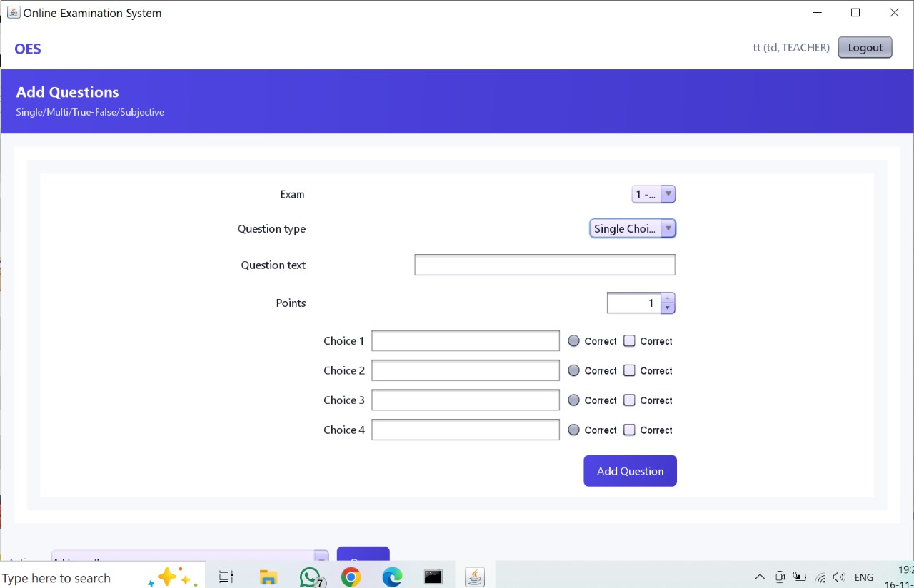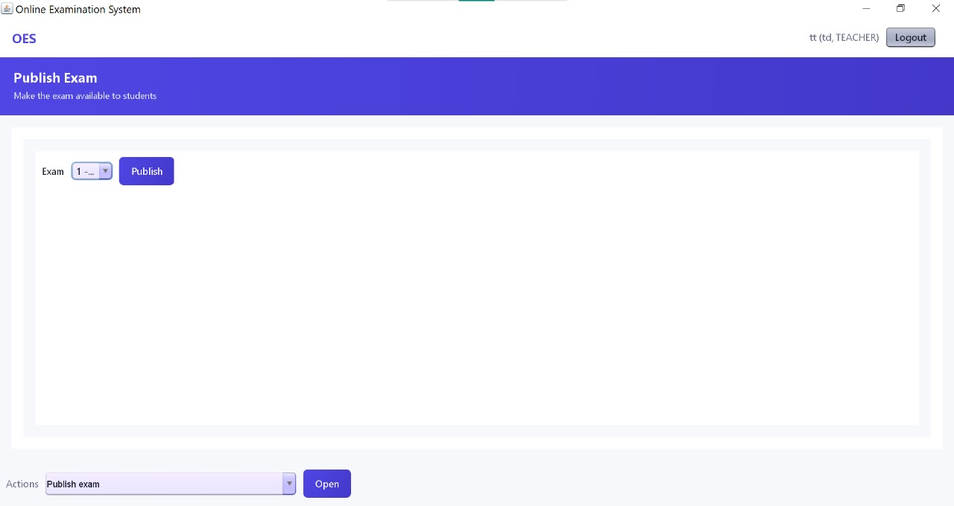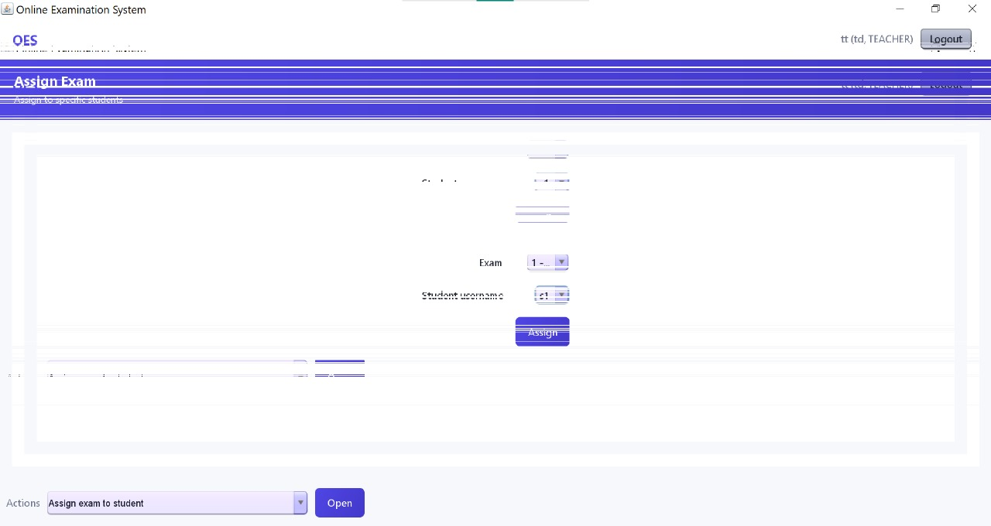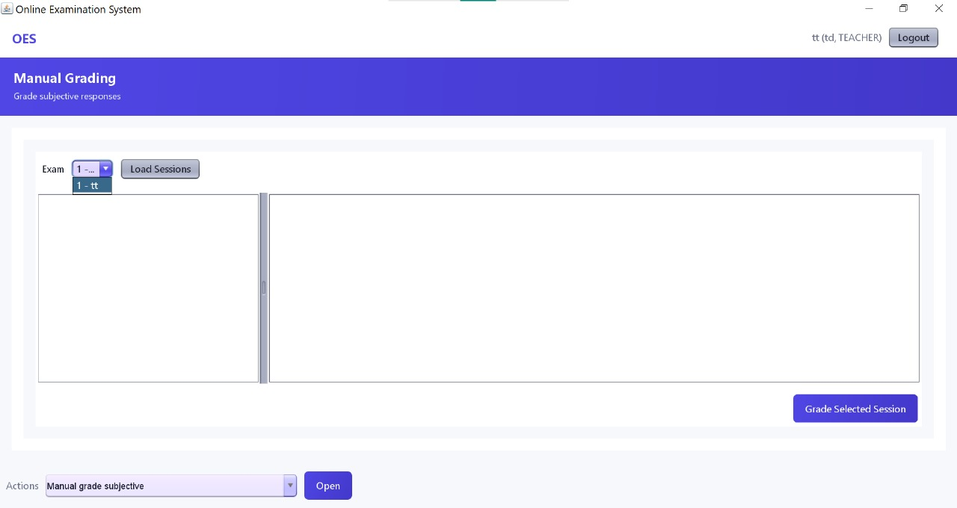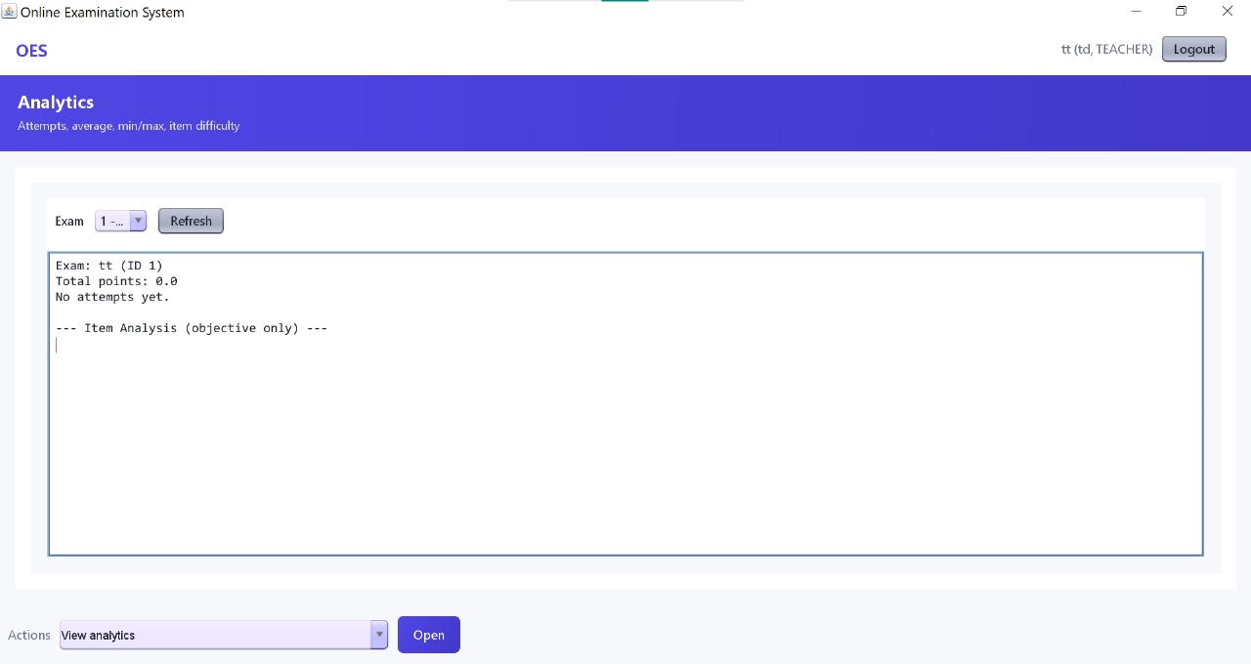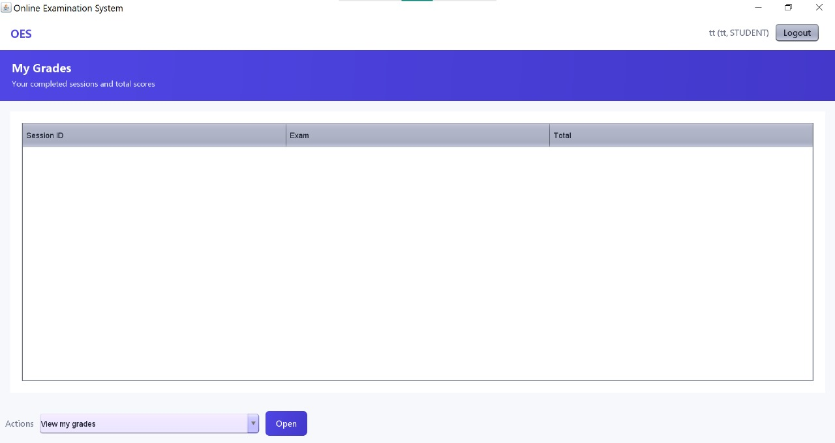

ANALYSIS
Usefulness of Training
This project provided deep exposure to:
- Real-world GUI development
- Application structuring
- Role-based interactive systems
- Logical and analytical thinking
- Debugging event-driven code
Technical Learnings
- Complete Swing programming
- State management for multi-role apps
- Custom UI component development
- Working with Card Layout & event listeners
- Designing scalable OOP models
- Building auto-grading algorithms
- Timer-based session tracking
- Multi-window communication via Dialog
Non-Technical Learnings
- Problem analysis and solution design
- UI/UX planning for user-friendliness
- Time management
- Documentation and testing
- Presentation skills
- Systematic debugging

Strengths of the Project
- Complete multi-role platform
- Smooth UI and intuitive navigation
- Auto + manual scoring
- Detailed analytics
- Secure single-attempt logic
- Full exam process flow implemented
Areas of Improvement
- Add database instead of arrays
- Provide login encryption
- Add graphs in analytics
- Add PDF result export
- Cloud-based exam access
- Mobile-friendly interface

CONCLUSION
The Online Examination System project allowed me to apply Java Swing and OOP concepts to build a complete working examination platform. It simulated the full lifecycle of a digital exam: creation, assignment, taking, grading, and analysis.
The project strengthened my understanding of GUI design, event handling, internal data management, and multi-role system implementation.
Overall, this project enhanced my technical foundation and improved my software problem-solving, making it a valuable learning experience.

References
- Java: The Complete Reference – Herbert Schildt
- Oracle Java Documentation
- GeeksforGeeks – Java Swing
- Stack Overflow
- TutorialsPoint – Java OOP & Swing
- Java SE API Documentation

